

Clinic Checkup Information System

Group 10

Names : Muhammad Fajrul Falah

Muhammad Yusuf Ilham Abdulhadi

Muhammad Nabiel Rayhan Falaah

Class : 2SE1

CEP CCIT

FAKULTAS TEKNIK UNIVERSITAS INDONESIA

2023

**Developed by**

1. **Muhammad Fajrul Falah**
2. **Muhammad Yusuf Ilham Abdulhadi**
3. **Muhammad Nabiel Rayhan Falaah**



**PROJECT ON**

*Clinic Checkup Information System*

**Clinic Checkup Information System**

Batch Code : 2SE1

Start Date : 12 April 2023   
End Date : 05 May 2023

# Name of Faculty : [M. Riza Iqbal Latief, ST.](https://ccit.eng.ui.ac.id/m-riza-iqbal-latief-st/)

Names of Developer :

1. Muhammad Fajrul Falah
2. Muhammad Yusuf Ilham Abdulhadi
3. Muhammad Nabiel Rayhan Falaah

Date of Submission: 05 May 2023

**CERTIFICATE**

This is to certify that this report titled “Clinic Checkup Information System” embodies the original work done by Muhammad Fajrul Falah, Muhammad Yusuf Ilham Abdulhadi and Muhammad Nabiel Rayhan Falaah. Project in partial fulfillment of their course requirement at NIIT.

Coordinator:

[M. Riza Iqbal Latief, ST.](https://ccit.eng.ui.ac.id/m-riza-iqbal-latief-st/)



**ACKNOWLEDGEMENT**

We thank the Almighty for providing us with strength and guidance. We are grateful to everyone who helped us complete our "Clinic Checkup Information System" project and special thanks to Mr. M. Riza Iqbal Latief, ST. as our lecturer and supervisor. Our project is a Java GUI application that links to a SQL Server DBMS via JDBC. It covers crucial clinic info system aspects like registration, appointments, health records, diagnoses, prescriptions, and referrals, but excludes pharmaceutical, payments, and inventory. We hope it serves as a helpful reference for those building a Java-based clinic checkup information system with JDBC.

Depok, May 2023

Author

**SYSTEM ANALYSIS**

**System Summary**:

The topic of this java programming project is Clinic Checkup Information System. In this project we will create a java GUI application which will be connected to SQL Server DBMS using JDBC. This project will cover certain area of Clinic Checkup Information Systems such as registration, appointment, health record, diagnosis, prescription, and referrals. This project will exclude the Pharmaceutical, Payment, and Inventory aspect of the clinic information system.

**DATABASE DIAGRAM**

**System Process**:

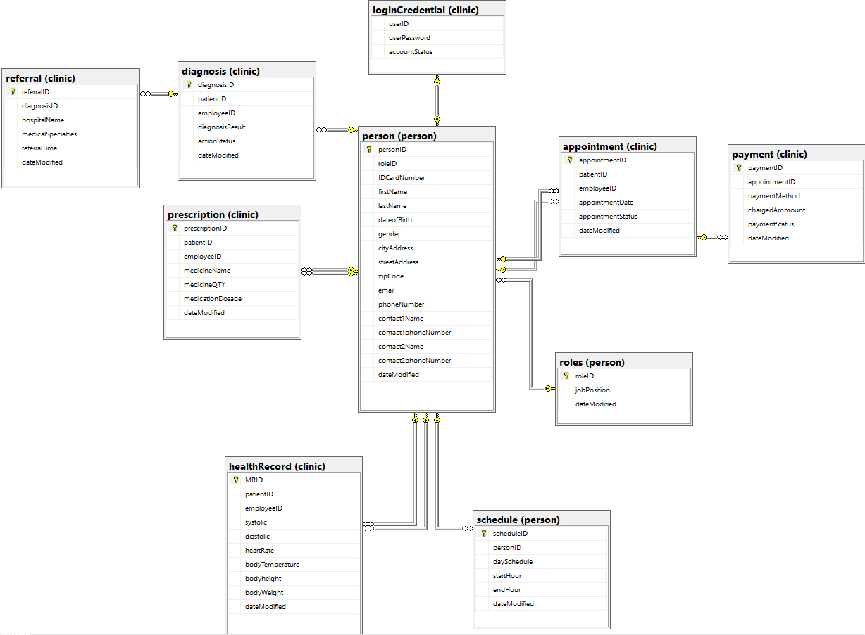

\

sssssssssss

**DATABASE QUERY: STRUCTURE**

**System Process**: Structure of the database (Database, Schema, Table)

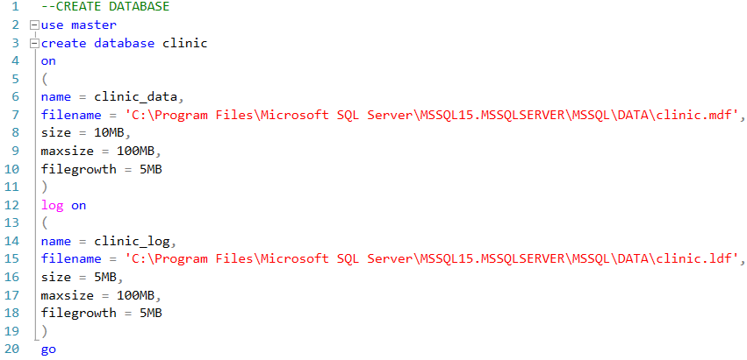

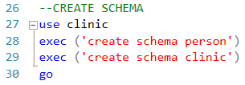

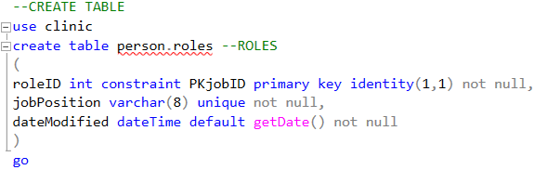

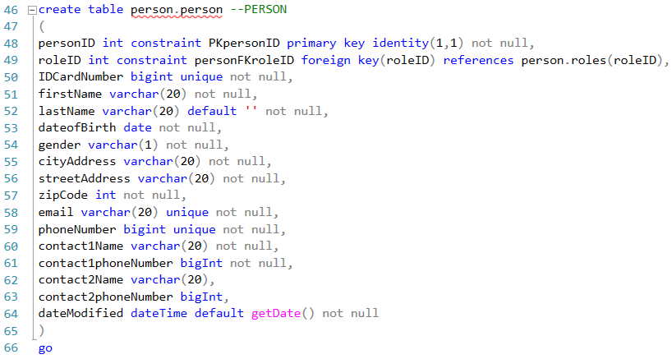

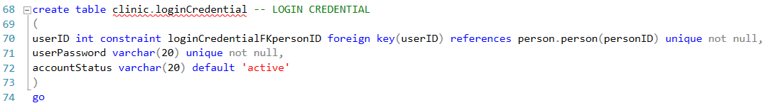

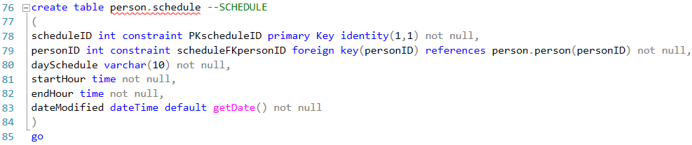

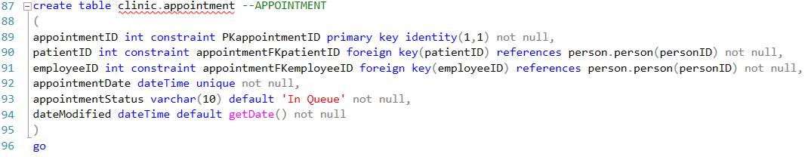

**DATABASE QUERY: STRUCTURE**

**DATABASE QUERY: STRUCTURE**

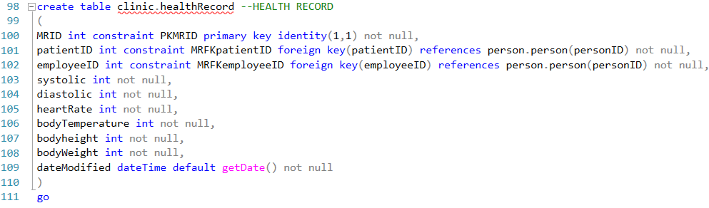

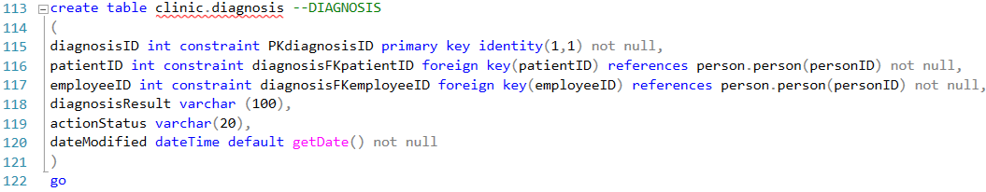

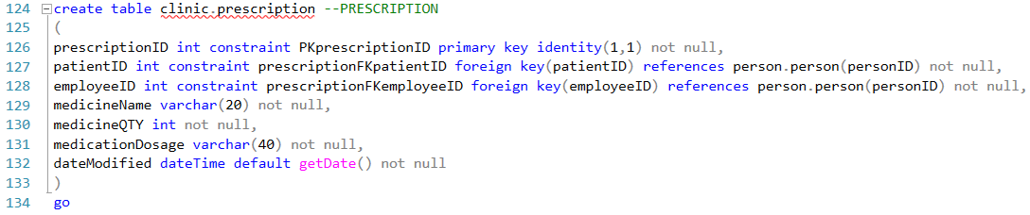

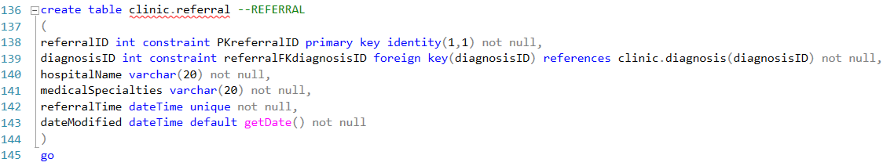

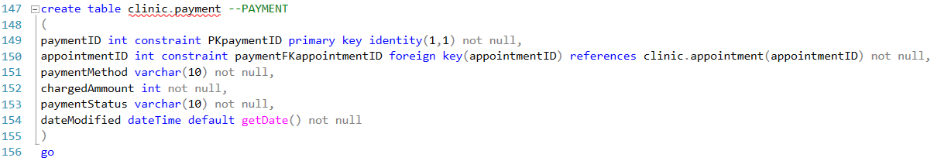

**DATABASE QUERY:   
STORED PROCEDURE**

**System Process**: Database stored procedure

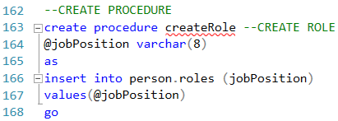

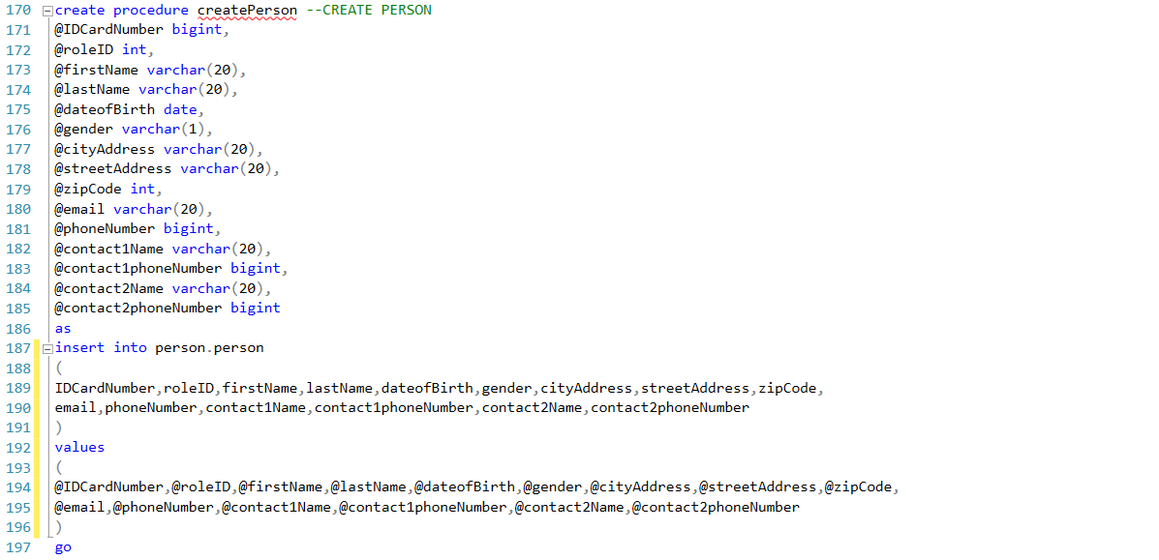

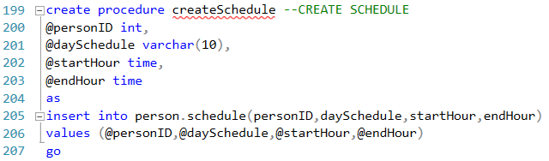

**DATABASE QUERY:   
STORED PROCEDURE**

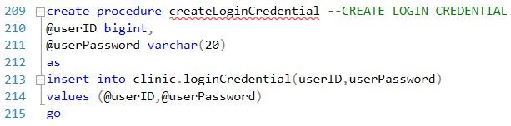

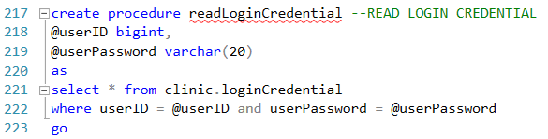

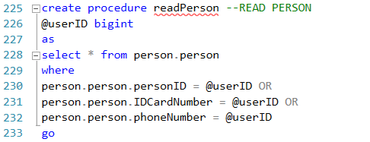

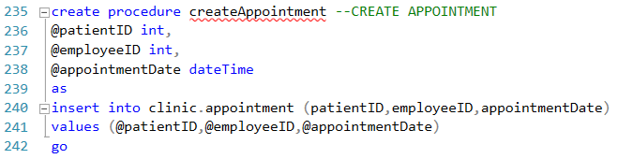

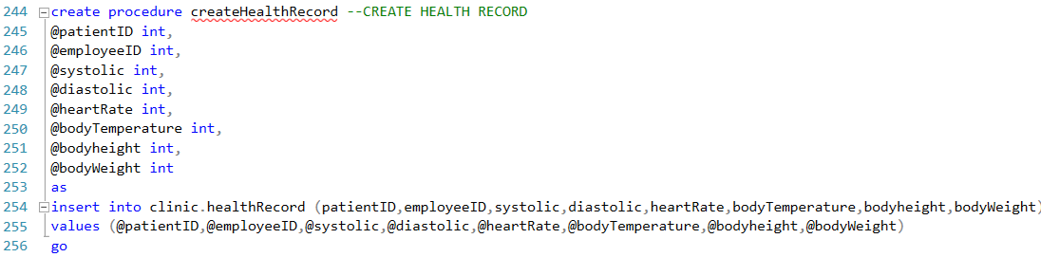

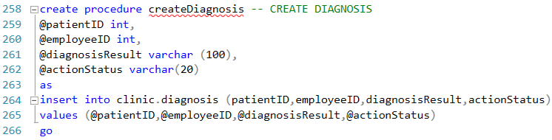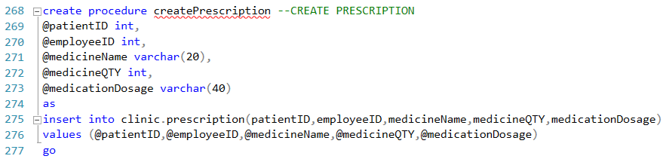

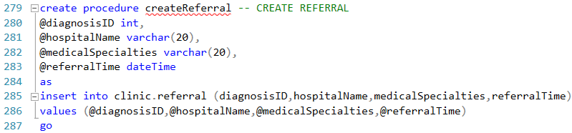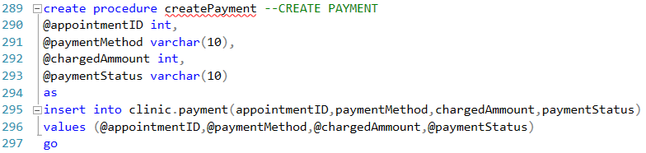

**DATABASE QUERY:   
STORED PROCEDURE**

**DATABASE QUERY:   
STORED PROCEDURE**

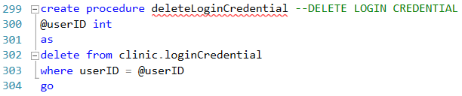

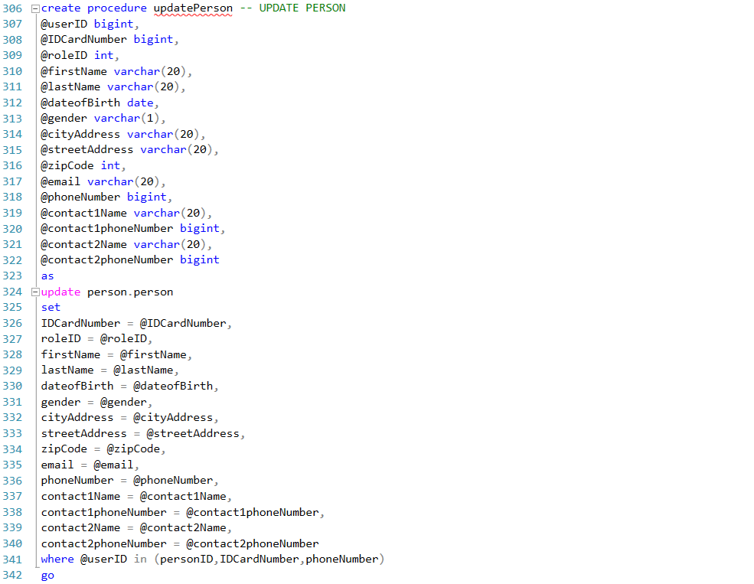

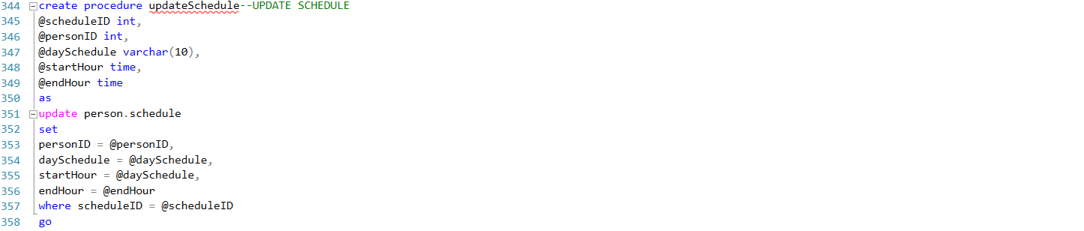

**DATABASE QUERY:   
STORED PROCEDURE**

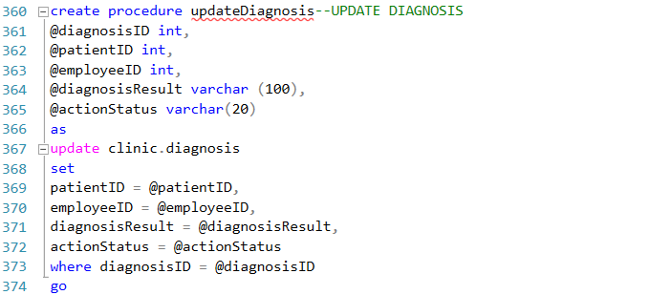

**DATABASE QUERY: VIEW**

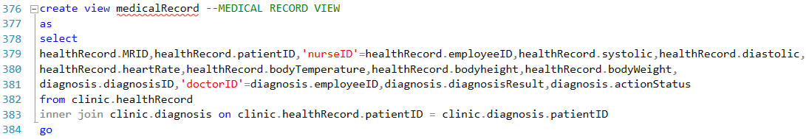

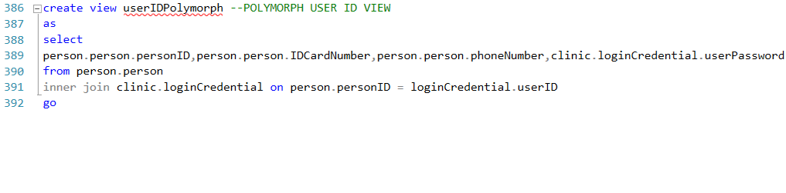

**DATABASE TEST DATA**

**System Process**: Data insertion result, using stored procedure

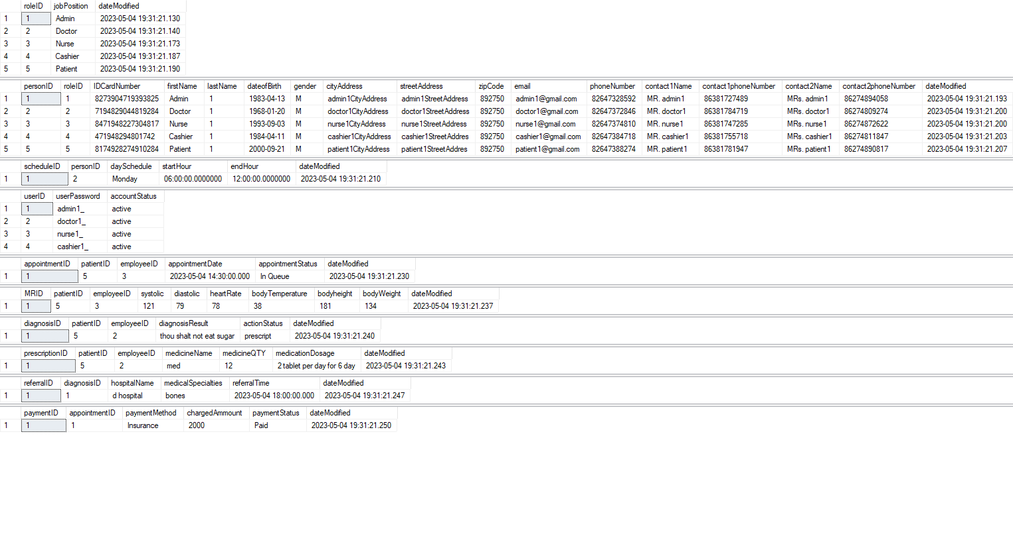

**GUI DESIGN**

**System Process**: Login Menu for directing to the role menu

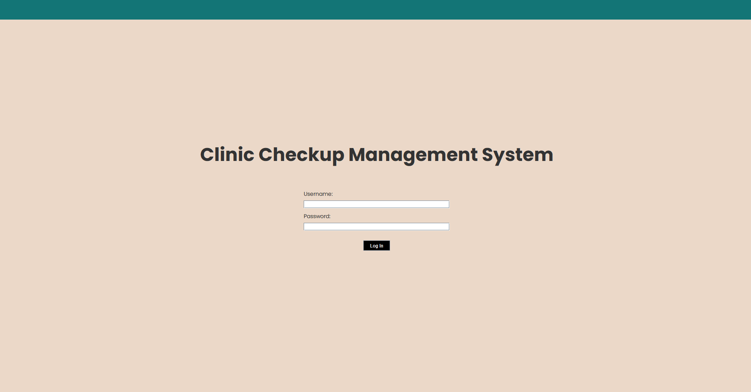

**System Process**: Doctor Menu

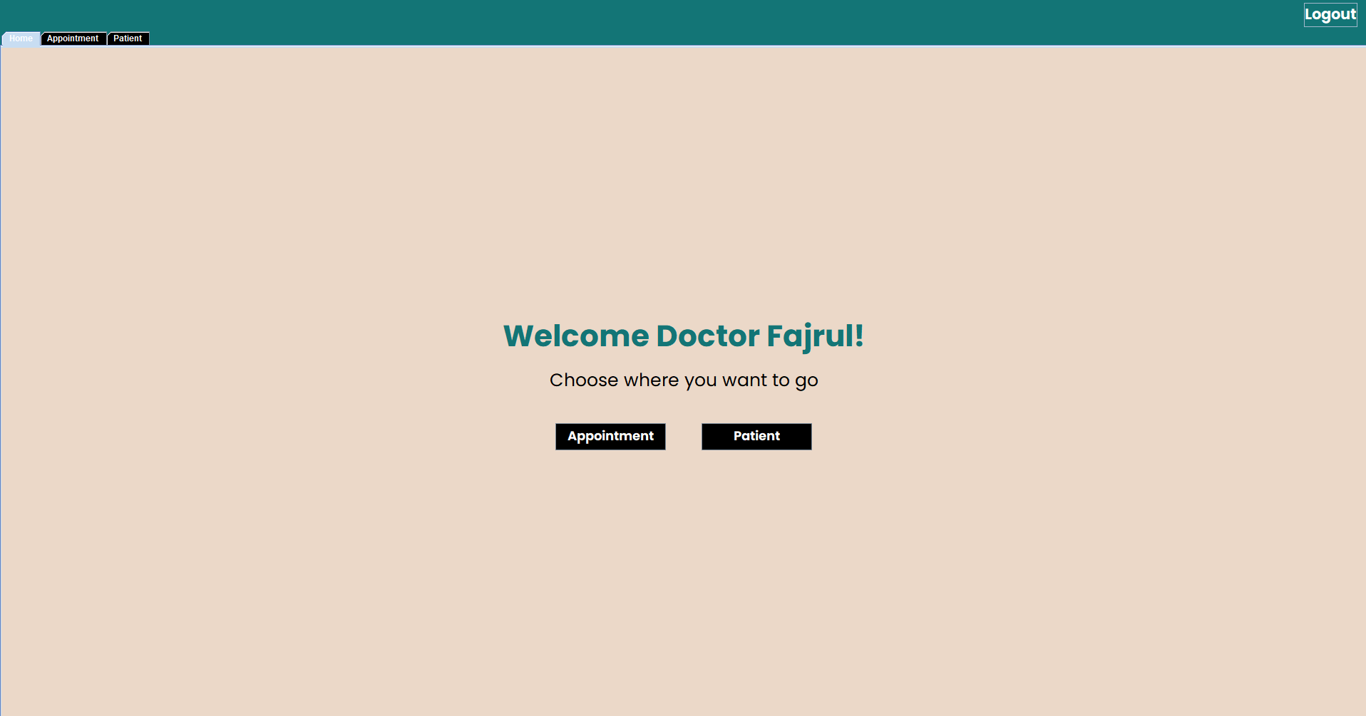

**System Process**: Edit Doctor’s Schedule Menu

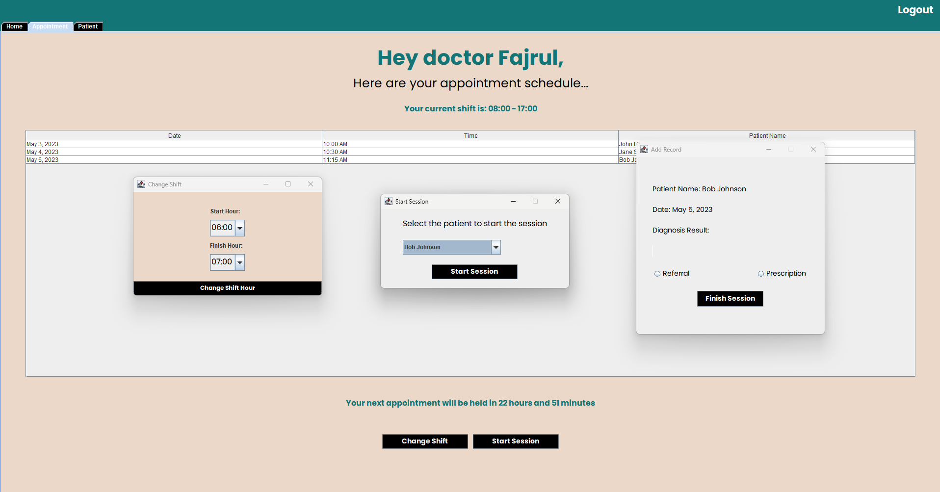

**System Process**: Patient’s History panel

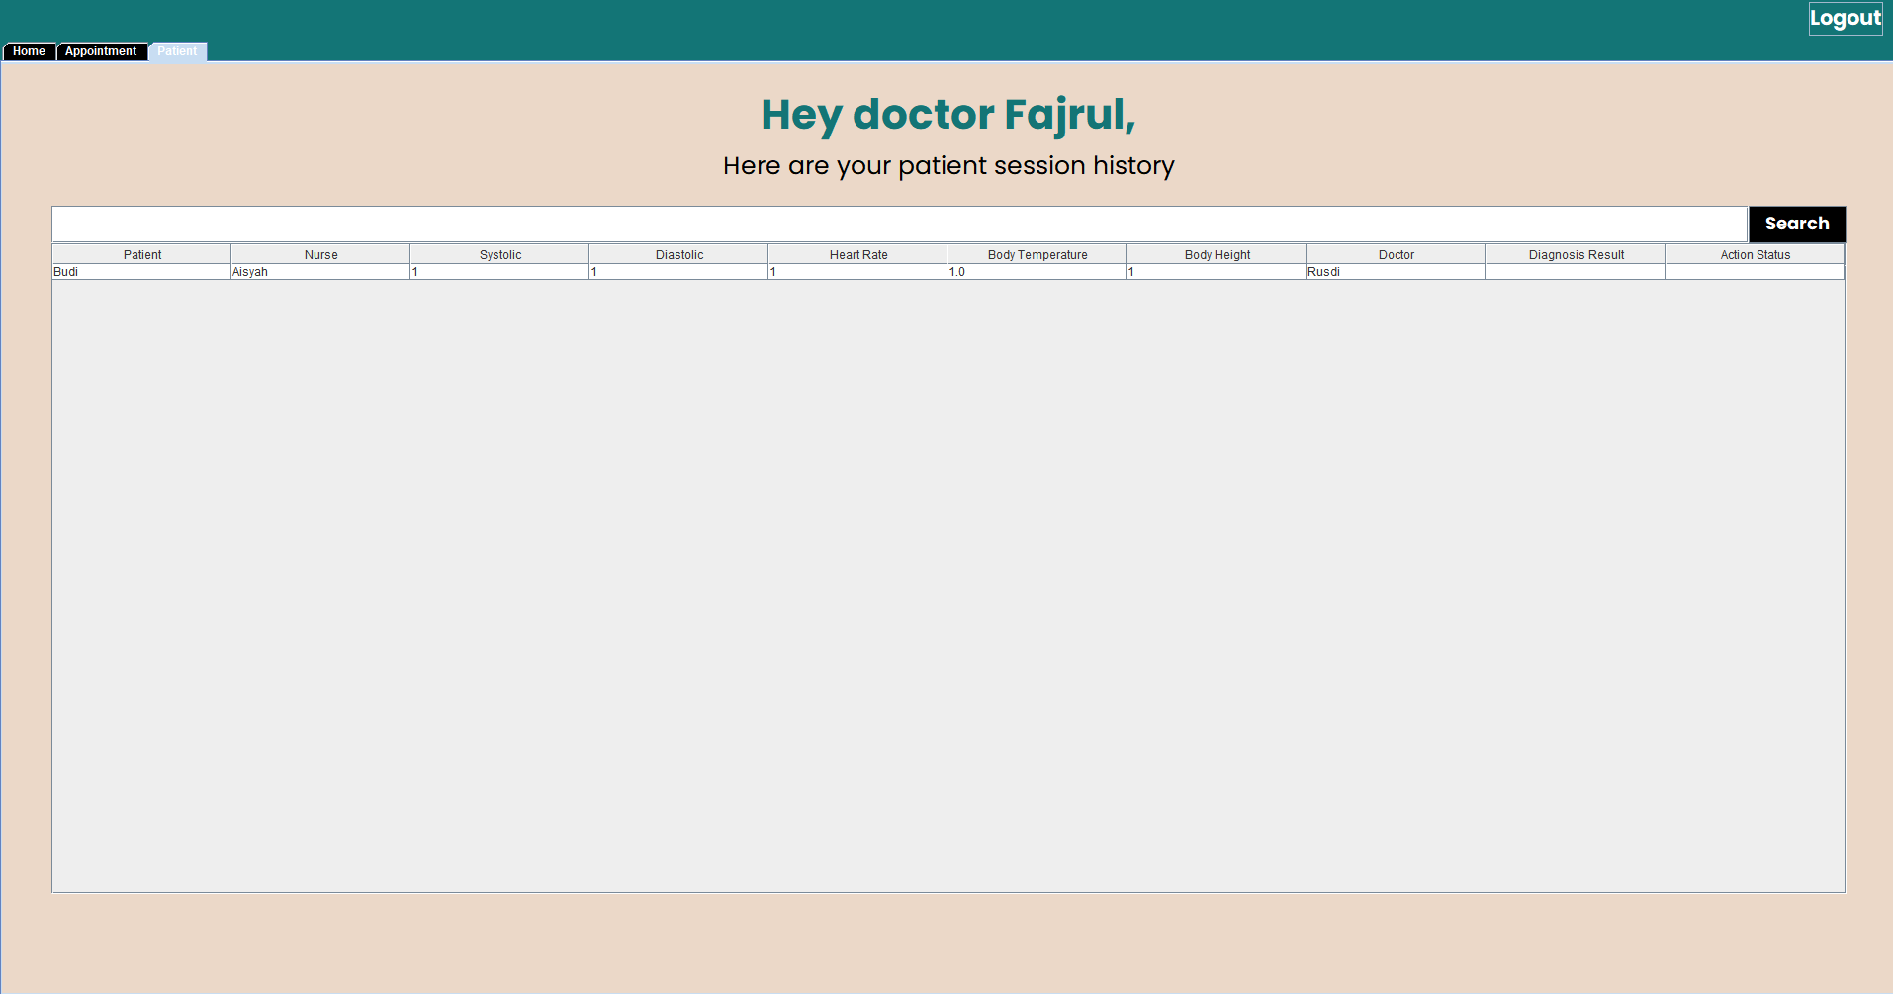

**GUI DESIGN**

**System Process**: Admin Menu

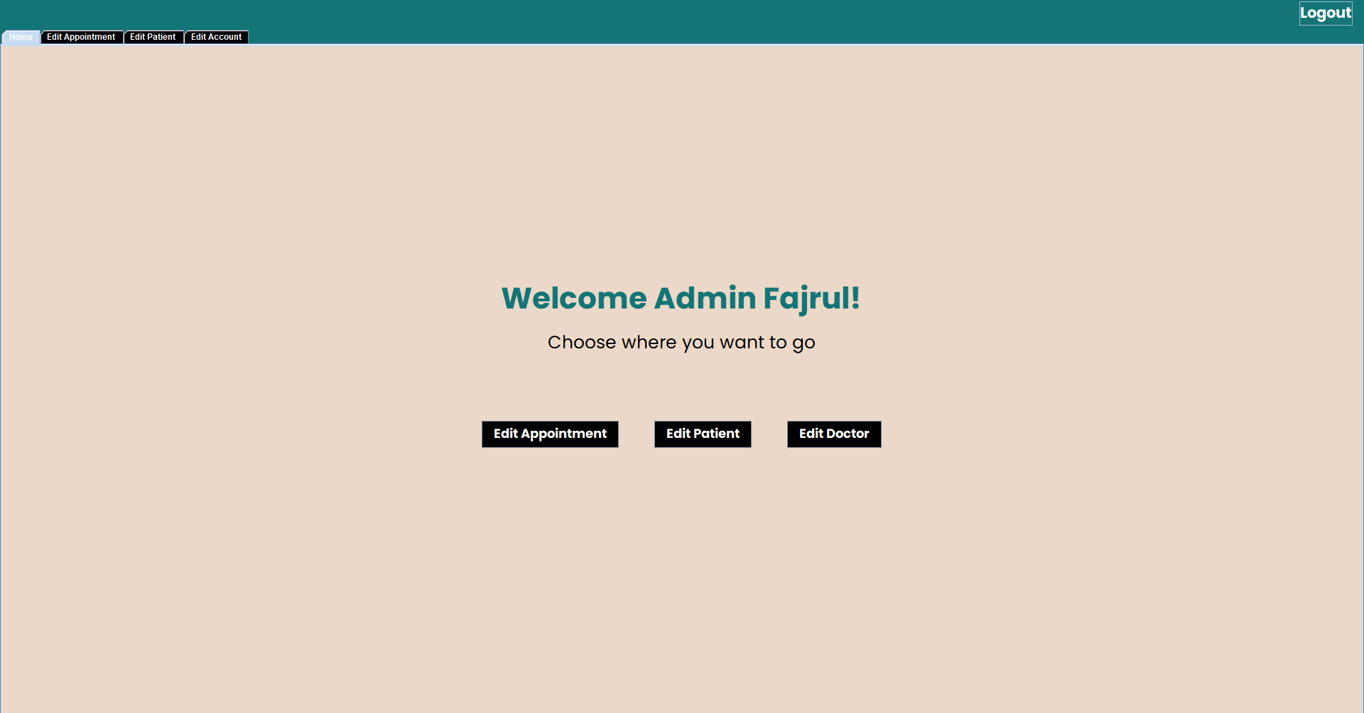

**System Process**: Edit Appointment Menu

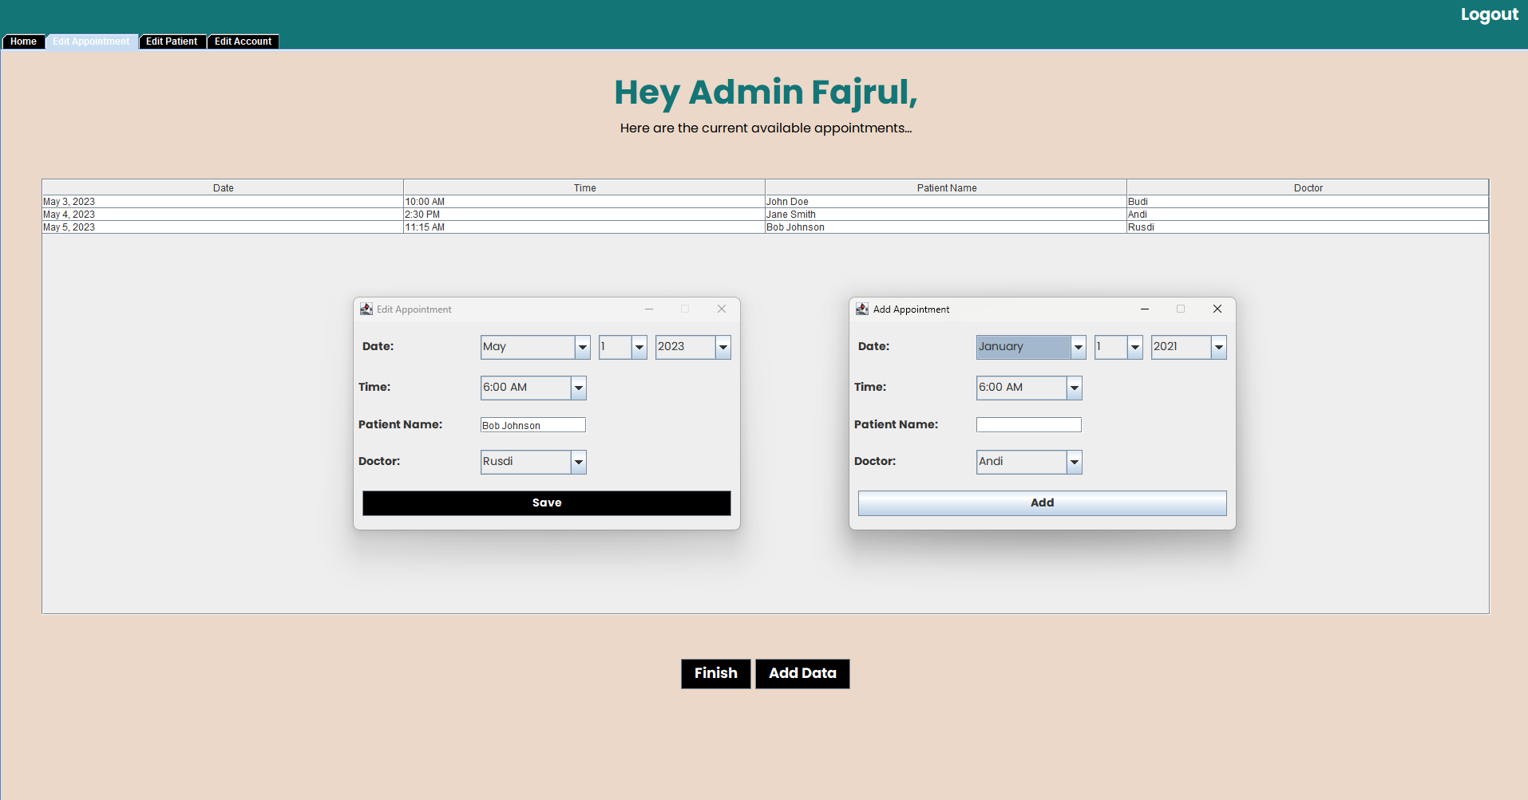

**GUI DESIGN**

**GUI DESIGN**

**System Process**: Edit Patient Menu

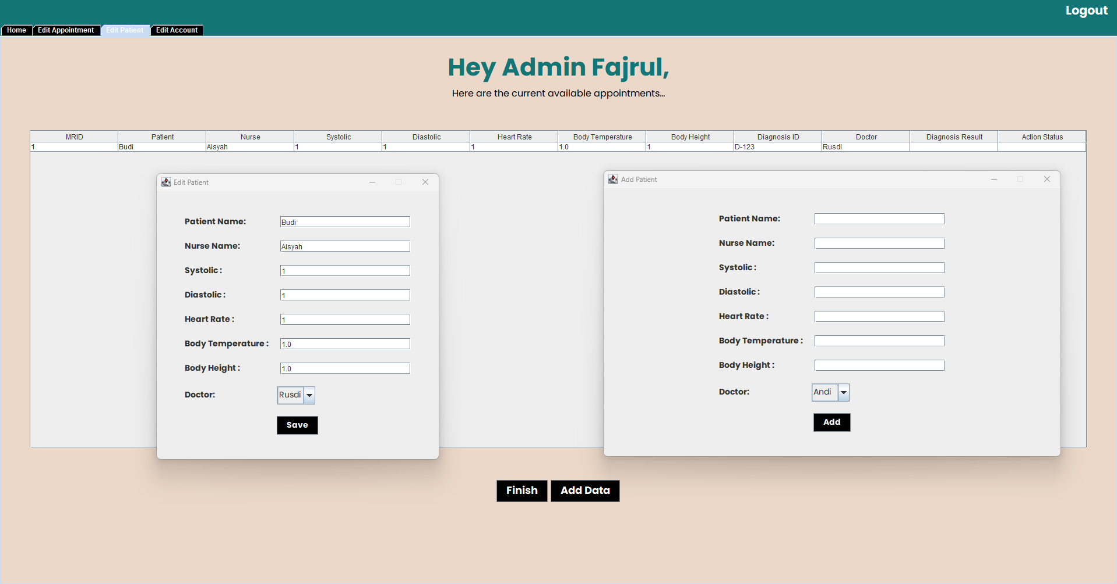

**System Process**: Edit Account Menu

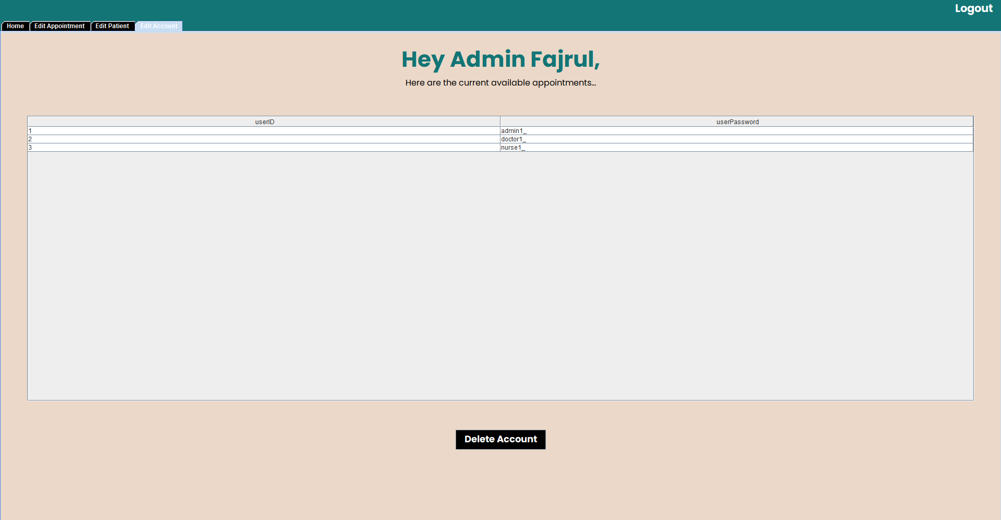

**CONFIGURATION**

**Hardware : Acer Swift X, Lenovo Yoga 7, HP EliteDesk**

**Operating System : Windows**

**Software : Visual Studio Code, Eclipse, Microsoft SQL Server Management Studio**

|  |  |  |
| --- | --- | --- |
| **PROJECT FILE DETAILS** | | |
| **S.No** | **File Name** | **Remarks** |
| 1. | Mssql-jdbc-12.2.0.jre8.jar | Miscrosoft sql jdbc library |
| 2. | App.java |  |
| 3. | LoginMenu.java |  |
| 4. | DoctorMenu.java |  |
| 5. | AdninMenu.java |  |
| 6. | AddAppointmentFrame.java |  |
| 7. | AddPatientFrame.java |  |
| 8. | AddRecord.java |  |
| 9. | EditAppointmentFrame.java |  |
| 10. | EditPatientFrame.java |  |
| 11. | servController.java |  |
| 12. | ShiftChange.java |  |
| 13. | StartSessionFrame.java |  |

\

sssssssssss